Risk Rating

Risk Assessment & Method Statement
Task/ activity: Municipal waste operations – tipping safely
Task/ activity description:
- Transport and sorting of Municipal Solid Waste.
- Receipt of Municipal Waste from delivery vehicles via ramps 3 & 4 or via bay 5.
- Loading of plant with a mechanical excavator.
- Operation / maintenance of sorting plant including manual intervention picking of larger items.
- Storage of sorted waste.
- Baling and stacking of waste for outward transport.

InductionS - All drivers on site must be inducted. if you have not been inducted, please scan the qr code below and complete the site induction

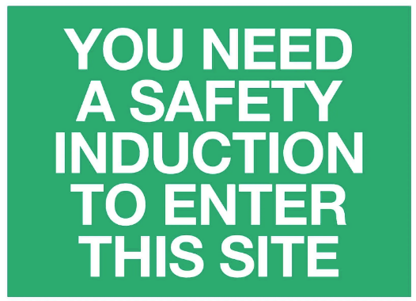
To help ensure the safety of everyone on site, please click the image below or scan the QR to watch a short safety video on the SSOW for the tipping procedure at Re-Gen.



Likely to be effected:

Risk Scoring = multiply severity by probability SxP=R
Severity | Probability | Risk Category
5 Fatality or disaster | 5 Highly likely
4 Major injury, damage or loss | 4 Very likely | High = 15-25
3 Reportable injury or occurrence | 3 Likely | Medium = 9-14
2 Minor injury, less than 3 days lost time or minimal loss | 2 Unlikely | Low = 1-8
1 Minor injury, no lost time or damage | 1 Very unlikely

Hazard | Control measures to be taken to reduce risk | Scoring |  | Risk Rating
Hazard | Control measures to be taken to reduce risk | S | P | Risk Rating
Vehicle/vehicle contact  - Loss/Damage to vehicles | - Drivers to be vigilant of their surroundings at all times.  - Only trained, competent and authorised personnel are permitted to operate plant and vehicles.  - Speed limit of 10mph is enforced on site. Signs displaying this information are positioned  - Machines have reversing cameras fitted where visibility is impaired. Vehicles are fitted with reversing warning beacons. These are kept in good working order.  - All plant and machine operators must hold and use a radio to maintain two-way contact at all times.  - Mobile phones are not permitted while operating vehicles.  - No hoods are permitted to be worn while driving or operating machinery.  - Only delivery drivers are permitted to exit the vehicle on site, passengers must wait within the vehicle.  - Passengers must disembark outside the gates, before the vehicle enters the site.  - All plant and machinery operators must complete pre-use checks on all plant/machinery/vehicles that they use at the start of their shift.  - Defects/damage to plant and machinery must be reported to the garage. Seriously defected/damaged equipment must not be used.  - A one-way system is in operation on-site. This must be adhered to by all large vehicles.  - During operating hours, all visitor and staff cars are restricted to the car park unless engaged in tasks requiring entry.  - Only essential, authorised personnel are permitted in the yard.  - All vehicles are provided with both external side mounted and rear-view mirrors, which should be kept clean and in good repair. If mirrors are damaged this must be reported to the garage.  - Physical stops, such as barriers or buffers, are in place to help warn drivers that they are at the limit of their safe reversing area.  SAFE STOP PROCEDURE  - The following procedure MUST be followed before leaving the seat of any vehicle, when anyone else approaches, and when anyone is working on the equipment:  - Fully apply the handbrake  - Make sure all controls and equipment are left safe, e.g. Controls in neutral, Stop the engine, Remove the key. | 4 | 2 | 8
Vehicle/Pedestrian Contact  - Death  - Major injury | - Visitors to the site must be greeted by their arranged chaperon and should be accompanied on site at all times.  - All new employees must receive the Health and Safety induction before being shown around the site and to their designated work area.  - No hoods to be worn while on the pedestrian walkway or in the yard.  - Sub-contractors must be inducted before being shown around the site and to their designated work area.  - Pedestrians should receive and carry with them at all times their ZoneSafe RFID tag. On receipt of this they must be instructed on the SSOW.  - All pedestrians in the yard must carry a radio and maintain two-way radio contact at all times.  - Machine operators must be notified to stop work on the floor when operatives are entering the floor areas. Pedestrians are to use the designated walkways.  - The 5-meter rule must always be obeyed. If a pedestrian is within 5 meters of a moving vehicle, this is classed as a near miss. Within 5 meters the operator must stop the vehicle, so long as it is safe to do so, attract the attention of the pedestrian and ensure positive communication is made. The operator can only move on once the pedestrian is no longer within 5 meters and it is safe to do so.  - Pedestrians must ensure positive communication (eye contact) is made with the vehicle operator before entering the work area.  - Hi-Vis jackets must be worn at all times throughout the site and on the plant.  - No one is allowed on the plant floor while the plant is in operation. Access to the plant floor must be authorized, and two-way radio contact must be maintained throughout the duration.  - No unauthorized personnel to be given access to the plant.  - Staff and visitors entering the office are restricted to the walkway, Hi- Vis vests/jackets must be worn at all times. | 5 | 2 | 10
Slips, trips and falls  - RIDDOR reportable Injury – fractures, bruising.  - Death | - Good housekeeping to be maintained on access to plant and machinery. Loose material to be removed on a regular basis. Pre-use checks to identify damage to steps/entrance.  - The floor is to be monitored and cleaned regularly to remove trip hazards.  - Maintenance operatives to plan the route where materials & tools need to be used.  - When maintenance/repairs are completed all debris needs to be cleaned up to maintain safe access and egress around the plant.  - Good housekeeping standards and practices are maintained to minimise the risk of slips and trips. Walkways are cleaned regularly throughout the shift and waste removed.  - Safety Footwear will be worn at all times. | 4 | 2 | 8
Contact with machinery  - Entanglement Entrapment  - Major injury | - All moving machinery is to be guarded.  - Guards must not be removed whilst the plant is operational.  - Guards must not be removed unless authorised.  - Daily inspections by plant operatives to ensure that guards are in place.  - Operatives to receive information, training and instruction for use of plant machinery.  - Pre-use checks to be completed prior to use of equipment. Damaged equipment must not be used. | 4 | 2 | 8
Noise  - Chronic hearing problems – deafness, tinnitus | - Noise surveys to be carried out at suitable intervals.  - All employees provided with hearing protection. Replacement hearing protection available.  - Employees to wear hearing protection during operations of the plant.  - Ear protection will be enforced.  - Signage is displayed.  - Staff to be given regular information and training in regards the hazards of the SRF plant and the effects of uncontrolled exposure. | 3 | 1 | 3
Dust  - Respiratory illness  - Explosion | - Dust masks with FFP3 protection are available.  - External dust surveys to be completed at suitable intervals.  - Findings from dust surveys to reviewed and relayed to operatives working in the area.  - Staff to be informed with regular information and instruction in the hazards and effects working the SRF plant.  - Operatives to practice good housekeeping to regularly remove dust and precent a dangerous build-up of dust. | 3 | 2 | 6
Work equipment  - Injury from poorly operated or maintained work equipment | - Pre-use checks to be completed prior to use of equipment.  - Only trained, competent and authorised operatives to operate or complete pre-use checks on plant machinery and equipment.  - Damaged equipment must not be used.  - Operatives to follow the SSOW when operating equipment.  - The public are to be excluded from the workplace. | 4 | 1 | 4
Crane Contact  - Impact  - Crush | - Crane operators are trained and instructed to park the crane in compliance with the five-meter rule when the driver is moving to the rear of the vehicle to commence the tipping operation.  - The crane operator must give a visual or audible signal when the tipping operation has finished.  - During maintenance of the crane the door to the tunnel must be isolated to prevent uncontrolled access. | 4 | 1 | 4
Lack of Hazard / Risk Awareness  - Personal injury | - All Operatives before Commencing any Plant & Equipment Maintenance must be given Job Specific Training by the Plant Manager.  - All Operatives must be Trained on the Risk Assessments & be able to Access them in their Speaking Language . | 4 | 1 | 4
Personal injury / Cuts / Abrasions  - Personal injury | - Individuals working in the area are to wear appropriate PPE in the intake area, Safety footwear, work gloves, and hard hat.  - All accidents & Incidents must be reported to the Plant Supervisor to help prevent reoccurrence, First Aid must be sought for any Injury no matter how minor,  - All Accidents & Incidents must be reported in compliance with accident reporting procedures | 4 | 1 | 4
Hit by Falling object  - Personal injury | - External Drivers should wear hard harts when discharging their load. | 4 | 1 | 4

Approval and review
Assessor: | Signature: | Position: | Date:
Wesley Jameson | 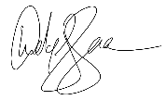 | Health & Safety Manager | May 2024
Approved by: | Signature: | Position: | Date:
Joseph Doherty | 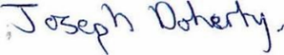 | Chief Executive Officer | May 2024
Reviewed on: | May 2024 | New version number: | 4
Date of next review: | May 2025, or as an when required
PPE required
- Safety gloves, safety boots, hi-vis clothing

Method statement

Traffic Light System
- The traffic lights system has been installed to ensure vehicle pedestrian separation when accessing the main building and production areas.
- The traffic light system is in place to stop the traffic using the same red, amber and green system that drivers are familiar with when crossing the road.
- The traffic lights system has audio and visual warnings for pedestrians to assist.
- The location of the traffic light management on site can be seen below.
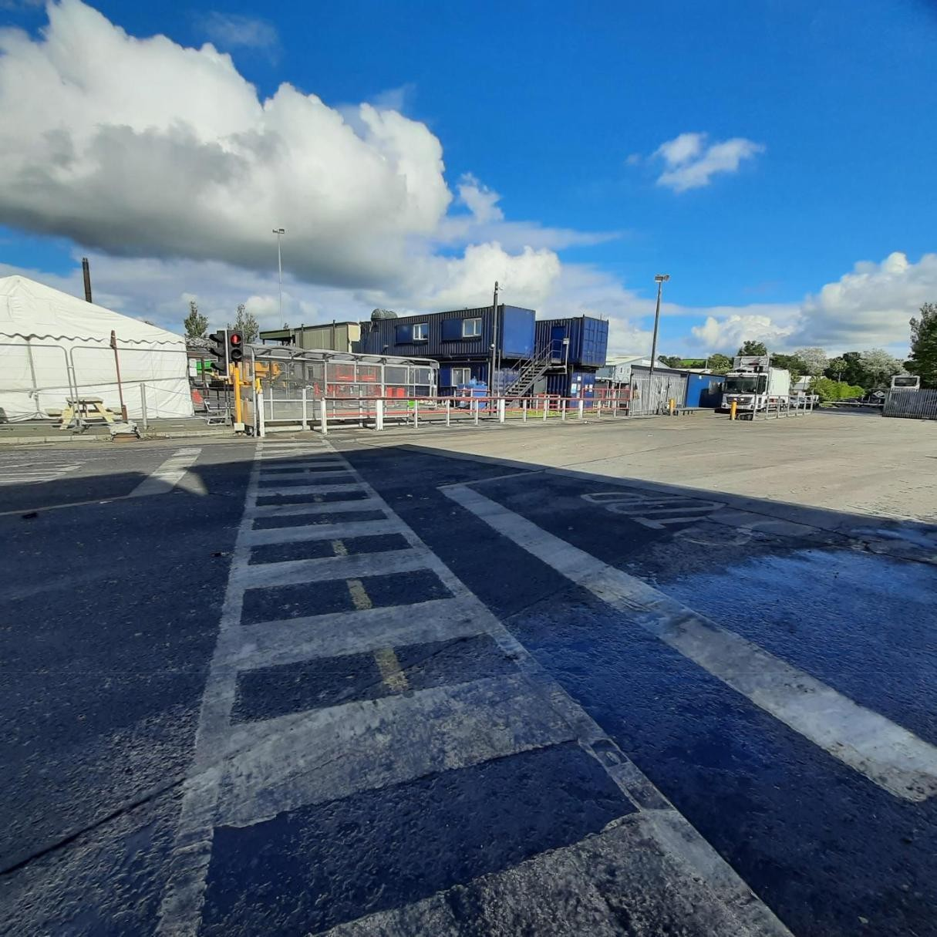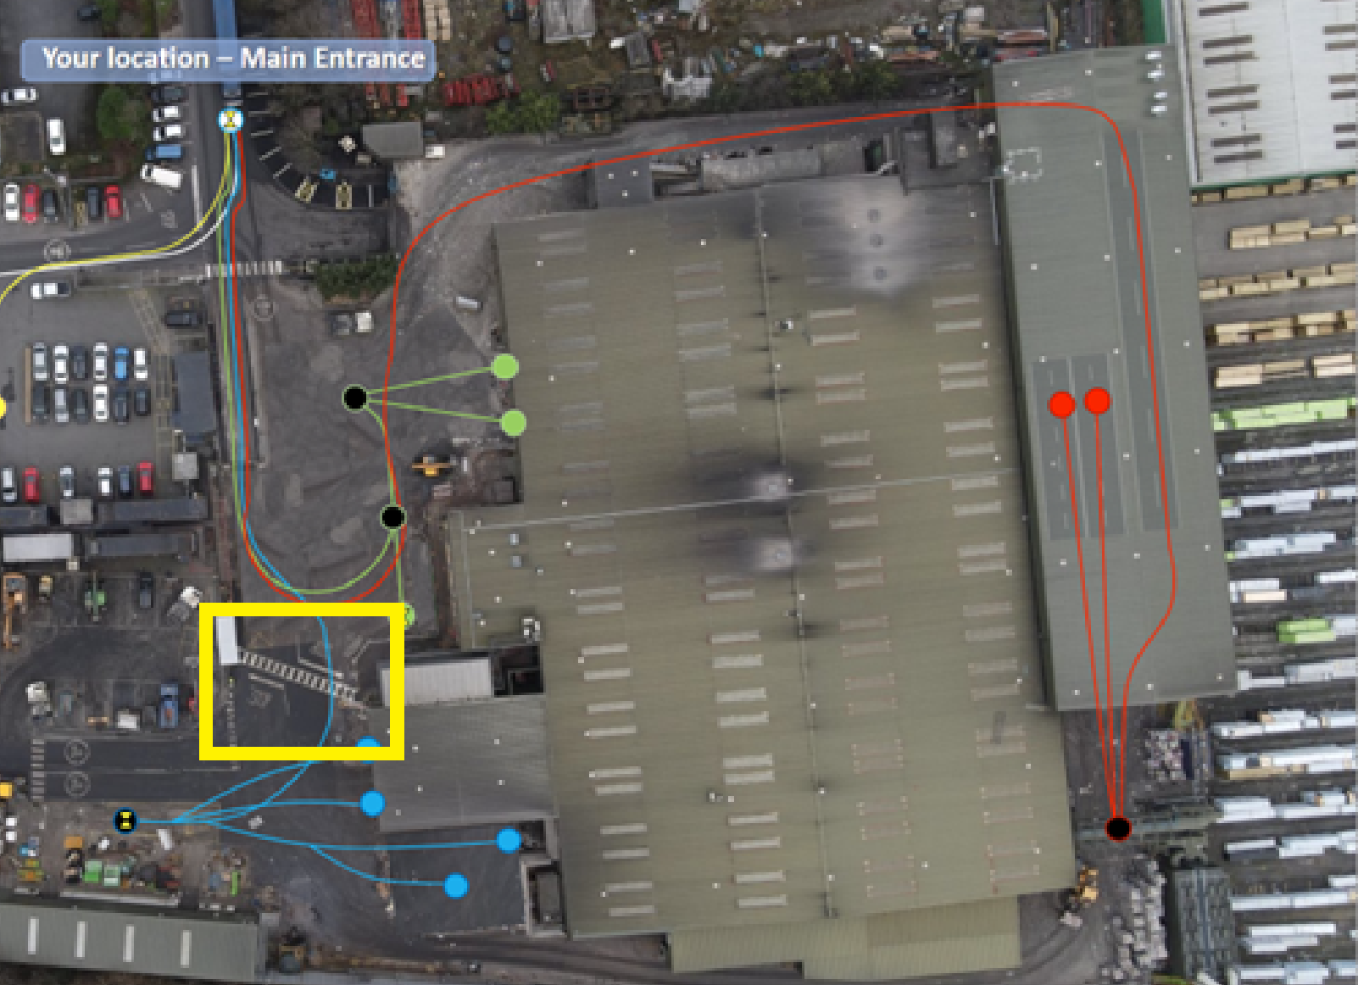

Traffic light system to access the doors 4 & 4 tunnel

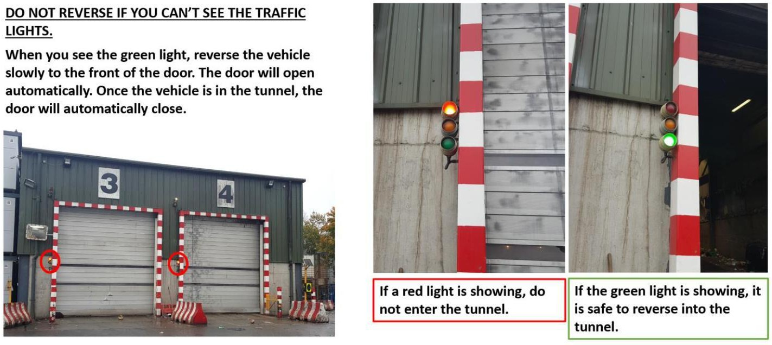

General site Rules:
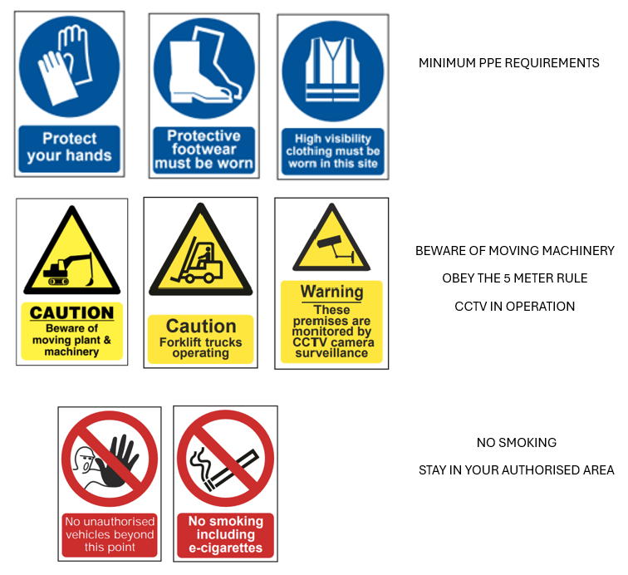
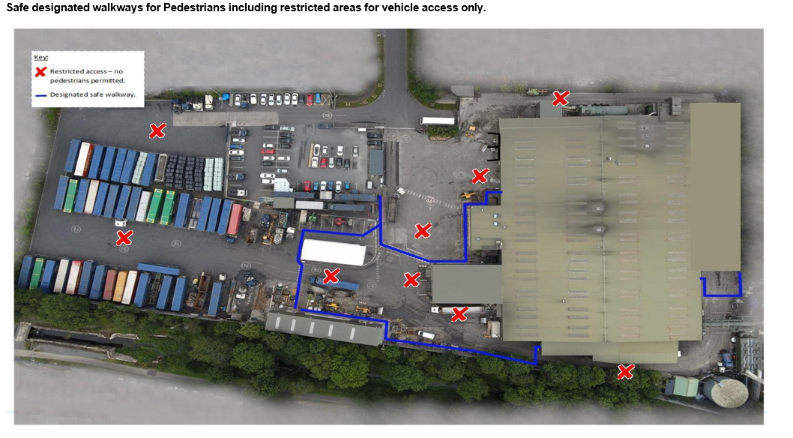
Summary & Types of traffic movements on site

External | Purpose | End Destination | Weighbridge | Point of access
Drivers | Purpose | End Destination | access | Point of access
HGV | Incoming | Door 1- 5 | Yes | Weighbridge
HGV | material | Door 1- 5 | Yes | Weighbridge
Bin Lorries | Incoming | Door, 1,2,3,4 | Yes | Weighbridge
Bin Lorries | material | Door, 1,2,3,4 | Yes | Weighbridge
Skip Lorries | Incoming | Door 5 | Yes | Weighbridge
Skip Lorries | material | Door 5 | Yes | Weighbridge
HGV Delivery | Incoming | Lorry Park | No | Lorry Park gate access
HGV Delivery | delivery | Lorry Park | No | Lorry Park gate access
Sub-contractors | Temporary | Dependent on scope | No | Dependent on scope of
Sub-contractors | works | of works | No | works
Visitor’s cars | Site visit | Car Park | No | Via turnstiles
Employee | Transporting | Designated parking | No | No access required
transport | employee’s | Designated parking | No | No access required
(Bus) |  | Designated parking | No | No access required
NIFRS | Emergency | Dependent on | No | Main gates to be opened in
NIFRS | Emergency | location of emergency | No | the event of an emergency
Ambulance | Emergency | Dependent on | No | Main gates to be opened in
Ambulance | Emergency | location of emergency | No | the event of an emergency

Site map
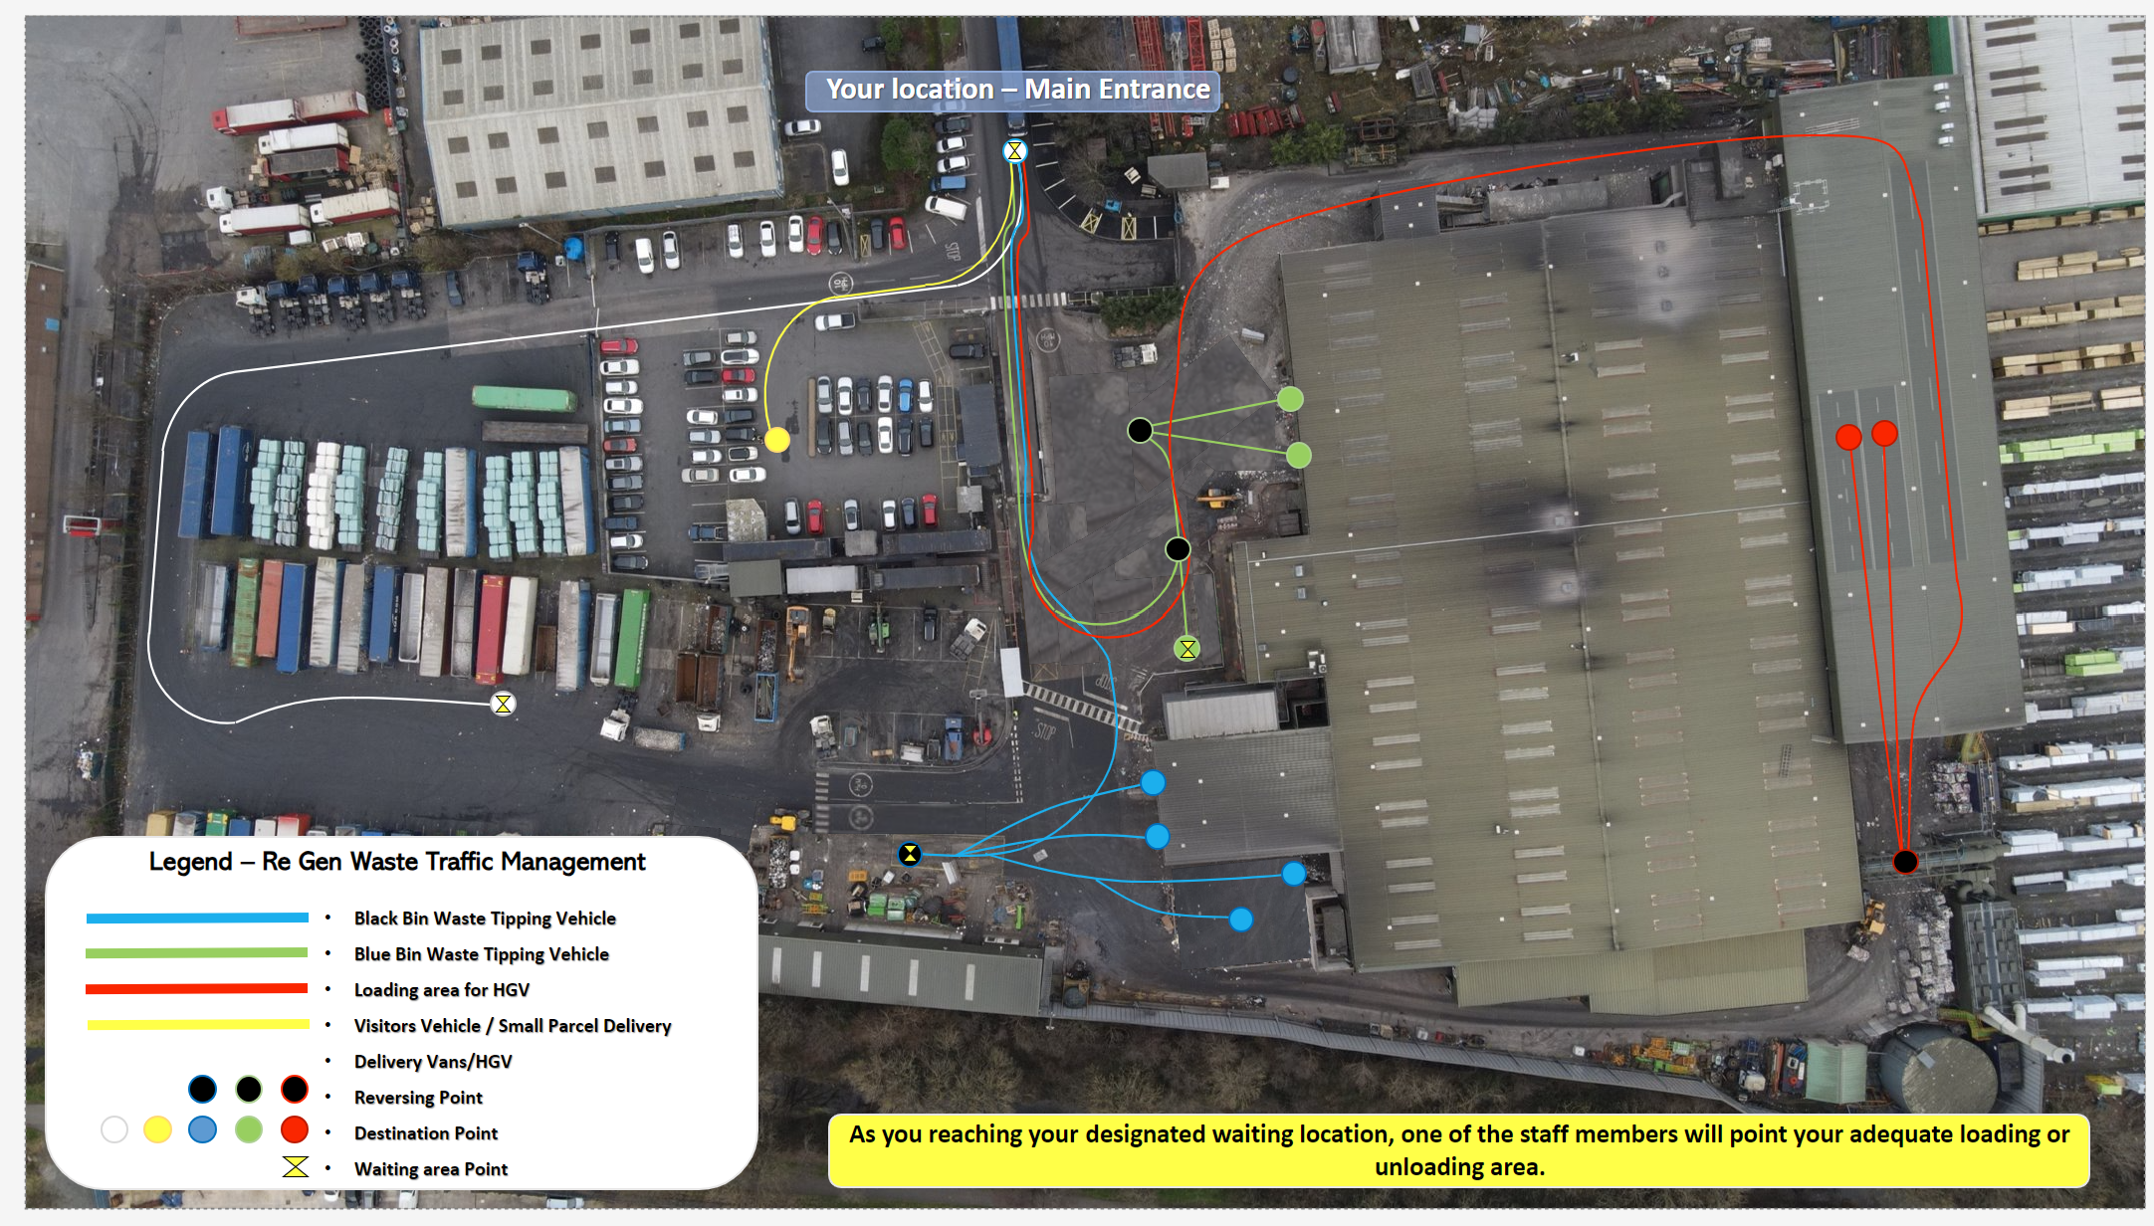
Emergency procedures
Contact details
In case of an accident or emergency, call 999 immediately.
- Daisy Hill Hospital – 028 3083 5000

